[Add to Bookmark](https://www.edureka.co/blog/interview-questions/docker-interview-questions/)  Email this Post  35K [**1**](https://www.edureka.co/blog/interview-questions/docker-interview-questions/#disqus_thread)

**Docker Interview Questions**

Docker containers can be considered as the new era of virtualization. Docker containers are replacing Virtual Machines, this is a well known fact now. So be prepared to answer few questions on Docker in your next interview. If you aspire to outshine yourself in your upcoming DevOps interview, going through these top Docker interview questions is a must. These questions are very carefully handpicked after discussing with many interviewers and experts. Curious to know more about Docker [***check out this Docker blog series***](https://www.edureka.co/blog/docker-tutorial).

This Docker Interview Questions blog is a part of parent blog [***DevOps Interview Questions***](https://www.edureka.co/blog/interview-questions/top-devops-interview-questions-2016/). It includes all the DevOps Stages.

*Before moving ahead, you may go through the webinar recording of DevOps Interview Questions where our instructor has shared his experience and expertise on Docker that will help you to answer any Docker question in your Interview:*

**DevOps Interview Questions and Answers | DevOps Training |**

First question in this blog on Docker Interview Questions has to be:

**Q1. What is Docker?**

I will suggest you to start with a small definition of Docker.

Docker is a containerization platform which packages your application and all its dependencies together in the form of containers so as to ensure that your application works seamlessly in any environment be it development or test or production.

Now you should explain Docker containers.

Docker containers, wrap a piece of software in a complete filesystem that contains everything needed to run: code, runtime, system tools, system libraries etc. anything that can be installed on a server. This guarantees that the software will always run the same, regardless of its environment.

You can refer the diagram shown below, as you can see that containers run on a single machine share the same operating system kernel, they start instantly as only apps need to start as the kernel is already running and uses less RAM.

**Note: Unlike Virtual Machines which has its own OS Docker containers uses the host OS**  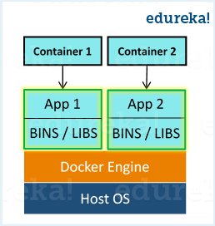

*As you have mentioned about Virtual Machines in your previous answer, so the next question in this Docker Interview Questions blog will be related to the differences between the two.*

**Q2. What are the differences between Docker and Hypervisors?**

You can refer the below differences:

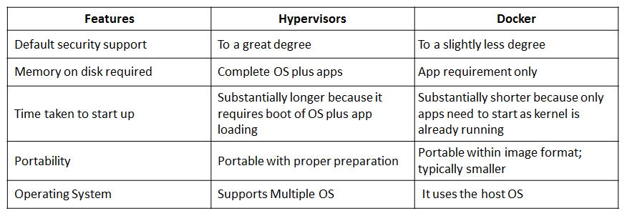

*Next set of Docker interview questions will focus on various components of Docker.*

**Q3. What is Docker image?**

I will suggest you to go with the below mentioned flow:

Docker image is the source of Docker container. In other words, Docker images are used to create containers. Images are created with the build command, and they’ll produce a container when started with run. Images are stored in a Docker registry such as registry.hub.docker.com because they can become quite large, images are designed to be composed of layers of other images, allowing a minimal amount of data to be sent when transferring images over the network.  
**Tip: Be aware of Dockerhub in order to answer questions on pre-available images.**

**Q4. What is Docker container?**

This is a very important question so just make sure you don’t deviate from the topic and I will advise you to follow the below mentioned format:

Docker containers include the application and all of its dependencies, but share the kernel with other containers, running as isolated processes in user space on the host operating system. Docker containers are not tied to any specific infrastructure: they run on any computer, on any infrastructure, and in any cloud.  
Now explain how to create a Docker container, Docker containers can be created by either creating a Docker image and then running it or you can use Docker images that are present on the Dockerhub.

Docker containers are basically runtime instances of Docker images.

**Q5 What is Docker hub?**

Answer to this question is pretty direct.

Docker hub is a cloud-based registry service which allows you to link to code repositories, build your images and test them, stores manually pushed images, and links to Docker cloud so you can deploy images to your hosts. It provides a centralized resource for container image discovery, distribution and change management, user and team collaboration, and workflow automation throughout the development pipeline.

[**Learn Docker With DevOps Now**](https://www.edureka.co/devops/)

**Q6.** **How is Docker different from other container technologies?**

According to me, below, points should be there in your answer:

Docker containers are easy to deploy in a cloud. It can get more applications running on the same hardware than other technologies, it makes it easy for developers to quickly create, ready-to-run containerized applications and it makes managing and deploying applications much easier. You can even share containers with your applications.  
If you have some more points to add you can do that but make sure the above the above explanation is there in your answer.

**Q7.** **What is Docker Swarm?**

You should start this answer by explaining Docker Swarn.

Docker Swarm is native clustering for Docker. It turns a pool of Docker hosts into a single, virtual Docker host. Docker Swarm serves the standard Docker API, any tool that already communicates with a Docker daemon can use Swarm to transparently scale to multiple hosts.

I will also suggest you to include some supported tools:

* Dokku
* Docker Compose
* Docker Machine
* Jenkins

**Q8. What is Dockerfile used for?**

This answer, according to me should begin by explaining the use of Dockerfile.

Docker can build images automatically by reading the instructions from a Dockerfile.

Now I will suggest you to give a small definition of Dockerfle.

A Dockerfile is a text document that contains all the commands a user could call on the command line to assemble an image. Using docker build users can create an automated build that executes several command-line instructions in succession.

*Now, the next set of Docker interview questions will test your experience with Docker.*

**Q9.** **Can I use json instead of yaml for my compose file in Docker?**

You can use json instead of yaml for your compose file, to use json file with compose, specify the filename to use for eg:  
**docker-compose -f docker-compose.json up**

**Q10.** **Tell us how you have used Docker in your past position?**

Explain how you have used Docker to help rapid deployment. Explain how you have scripted Docker and used Docker with other tools like Puppet, Chef or Jenkins.

If you have no past practical experience in Docker and have past experience with other tools in a similar space, be honest and explain the same. In this case, it makes sense if you can compare other tools to Docker in terms of functionality.

**Q11. How to create Docker container?**

I will suggest you to give a direct answer to this.

We can use Docker image to create Docker container by using the below command:

|  |  |
| --- | --- |
| 1 | docker run -t -i command name |

This command will create and start a container.

You should also add, If you want to check the list of all running container with the status on a host use the below command:

|  |  |
| --- | --- |
| 1 | docker ps -a |

**Q12. How to stop and restart the Docker container?**

In order to stop the Docker container you can use the below command:

|  |  |
| --- | --- |
| 1 | docker stop container ID |

Now to restart the Docker container you can use:

|  |  |
| --- | --- |
| 1 | docker restart container ID |

Q13 How far do Docker containers scale?

Large web deployments like Google and Twitter, and platform providers such as Heroku and dotCloud all run on container technology, at a scale of hundreds of thousands or even millions of containers running in parallel.

Q14. What platforms does Docker run on?

I will start this answer by saying Docker runs on only Linux and Cloud platforms and then I will mention the below vendors of Linux:

* Ubuntu 12.04, 13.04 et al
* Fedora 19/20+
* RHEL 6.5+
* CentOS 6+
* Gentoo
* ArchLinux
* openSUSE 12.3+
* CRUX 3.0+

Cloud:

* Amazon EC2
* Google Compute Engine
* Microsoft Azure
* Rackspace

**Note that Docker does not run on Windows or Mac.**

**Q15. Do I lose my data when the Docker container exits?**

You can answer this by saying, no I won’t lose my data when Docker container exits, any data that your application writes to disk gets preserved in its container until you explicitly delete the container. The file system for the container persists even after the container halts.

**Q16. Mention some commonly used Docker command?**

Below are some commonly used Docker commands:

